

June 8th , 2010
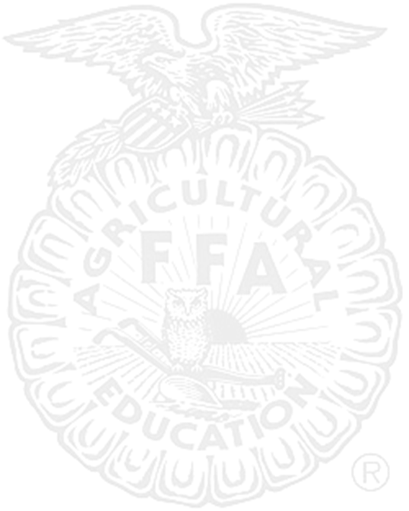
To who it may concern:

Hello my name is Suzzie Doe and I am a member of the Heritage FFA Chapter. FFA is a national youth organization which promotes personal growth, premier leadership and career success through agricultural education. Within this organization I am a student in ag Biology, a chapter officer, I show livestock, and participate in multiple public speaking events and other FFA competitions throughout the state.

Over the past few months I have been raising, feeding, cleaning, and practicing with my swine project for the upcoming fair in October. I really hope to sell my pig at the fair or to a private buyer prior to the fair. All the procedes for my animal will go to my future projects and other edication goals I have for my future. To accomplish this however I need to find buyers and or sponsors for my project. By purchasing or sponsoring an animal from me you can help me in my goal of obtaining the golden California State FFA Degree which is a huge honor that I have been working towards. This degree is obtained by the top 3% of FFA members in California.

If interested I need to sell my animal for at least $2.00 per pound. Not only would you get 100% grain fed pork, very high end qulailty product that taste much better than what you find in the stores, but there is also a tax deduction letter available.

I look forward to speaking with you about any questions, comments or concerns you may have. Please feel free to contact me anytime at (951)555-5555 or at 123456@myemail.com. Thank you for your time.

Suzzie Doe
Menifee-Heritage FFA Chapter
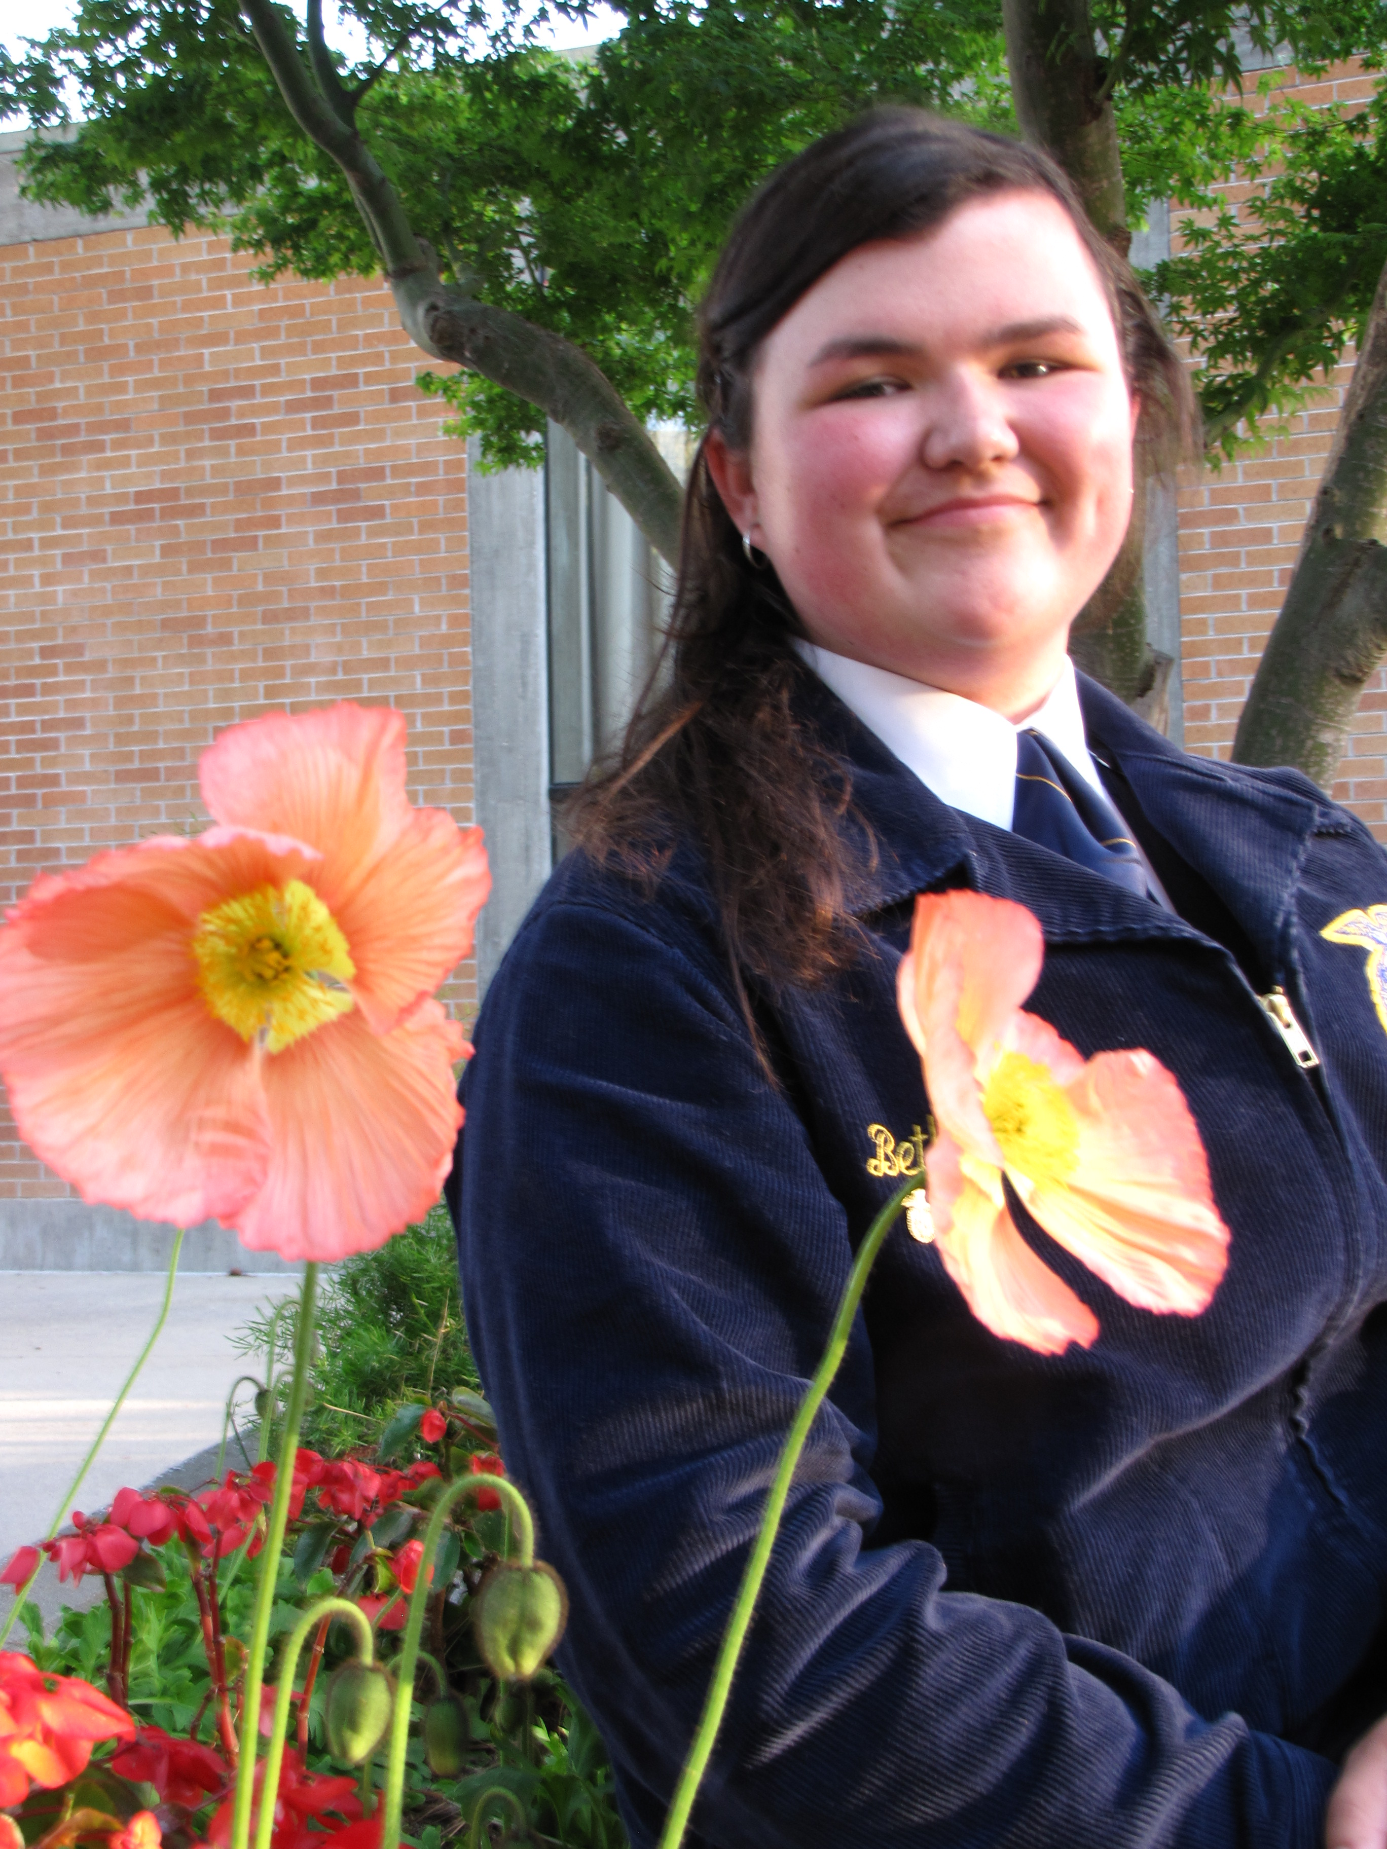
26001 Briggs Rd. Menifee CA

